3a-1 Domain, DNS and TLS Certificates with Let's Encrypt

Class Activity Overview
This lab introduces students to setting up a complete Internet-facing web presence. Students will configure a cloud VM, purchase and link a domain name, set DNS records, and secure their site with HTTPS using Let's Encrypt. The goal is to empower students to create real online services with full control.

Learning Objectives
- - Launch a cloud VM and configure firewall access (ports 22, 80, 443).
- - Install and run a basic Apache web server.
- - Purchase and manage a domain name via a registrar.
- - Link domain to VM public IP using DNS A record.
- - Verify domain resolution using ping and nslookup.
- - Obtain and install a TLS certificate via Let’s Encrypt.
- - Understand DNS propagation, redundancy, and failover behaviour.

Lab Setup and Tasks
- - Launch Ubuntu VM using Amazon EC2, Azure, or DigitalOcean.
- - Ensure inbound ports 22 (SSH), 80 (HTTP), and 443 (HTTPS) are open.
- - Install Apache: `sudo apt install apache2`.
- - Record public IP address of the VM. Access in browser to confirm Apache page.
- - Register a domain (Namecheap, GoDaddy, Cloudflare, Route 53, etc).
- - Create an A record pointing your domain to the public IP of your server.
- - Wait for DNS propagation and test with browser, ping, and nslookup.
- - Install Certbot: `sudo apt install certbot python3-certbot-apache`.
- - Run: `sudo certbot --apache` to generate and install the certificate.
- - Check site: HTTPS lock icon should appear in browser.

Experimentation and Advanced Tasks
- - Who issued the SSL certificate for murdoch.edu.au and csn.murdoch.edu.au?
- - Can you use a subdomain to point to another student’s server?
- - Create two A records with different IPs. Observe failover behaviour.
- - Shutdown server and observe DNS delay in failover. Discuss why.
- - Reflect on DNS load balancing, round-robin, and high-availability use cases.

Budget and Cost Monitoring
- - Visit EC2 Billing Dashboard to monitor charges.
- - Set a budget and create usage alerts under AWS Budgets.
- - Terminate unused instances to avoid unnecessary charges.
- - Avoid running expensive instance types (e.g. with GPUs) if not required.
- - Disable domain auto-renew if not continuing use post-semester.

Reflection Questions
- - What is the role of DNS in Internet presence?
- - Why does DNS propagation take time?
- - How does Let’s Encrypt validate domain ownership?
- - What are the risks if TLS is not configured on a public-facing site?
- - What could happen if you leave your cloud VM running for months?

🟢 Activity 1: Domain, DNS
📦 Deliverables:
# | Deliverable | Description
1 | Domain Name Registered | A registered domain from Namecheap, GoDaddy, Route 53, or similar: Duckdns.org/domain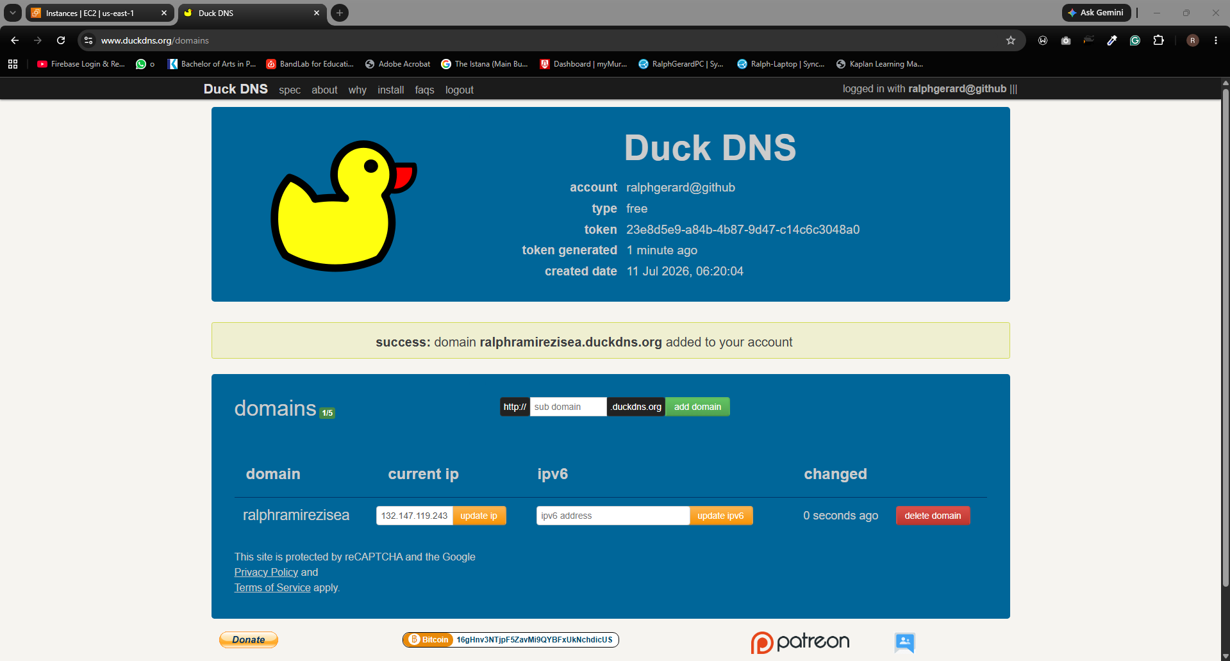
2 | A Record Created | DNS A record pointing your domain to your VM's public IP
3 | Apache Installed | Apache2 running and accessible on port 80
4 | Public IP to Domain Mapping Verified | Test using nslookup, dig, and browser to confirm DNS is working
5 | Screenshot: Apache Welcome Page via Domain | Open http://yourdomain.com and capture the Apache welcome page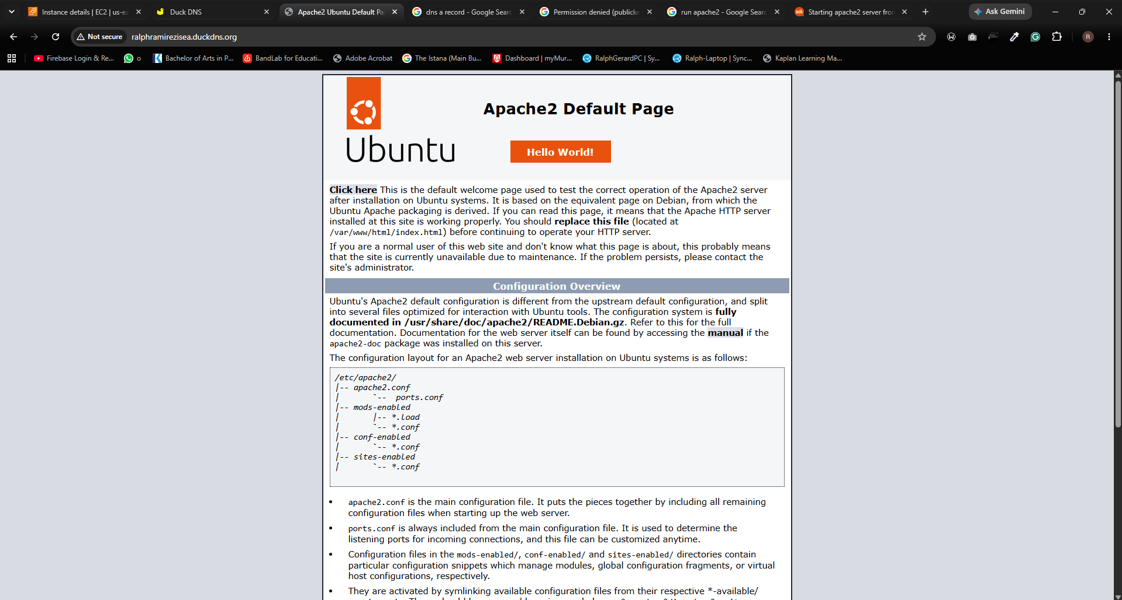
6 | Screenshot: DNS Test Output | Output of nslookup yourdomain.com or dig  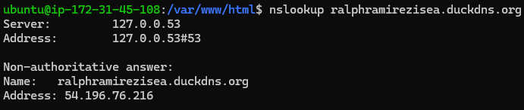
7 | (Optional) Subdomain Experiment | A record pointing a subdomain (e.g., test.yourdomain.com) to another IP and screenshot of test result

🟢 Activity 2: Let’s Encrypt TLS Certificate Setup
You secure your domain with HTTPS by installing a free Let's Encrypt TLS certificate using Certbot.
📦 Deliverables:
# | Deliverable | Description
1 | Certbot Installed | Certbot and Apache plugin installed via Snap
2 | HTTPS Enabled on Domain | https://yourdomain.com should show a secure lock icon
3 | Valid TLS Certificate | Certificate issued by Let’s Encrypt (viewable in browser)
4 | Screenshot: HTTPS with Lock Icon | Browser screenshot showing lock and certificate issuer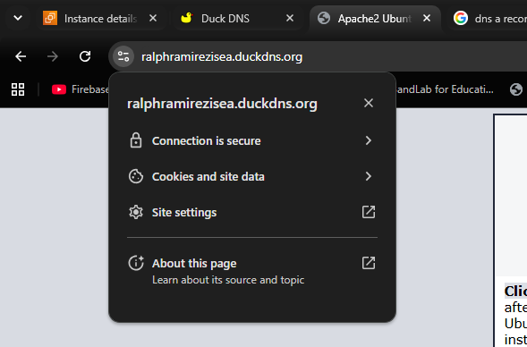
5 | Screenshot: Certbot Success Message | Output of sudo certbot --apache command  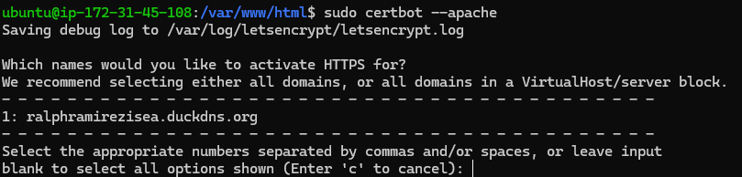
6 | Screenshot: Renewal Dry-Run Output | Output of sudo certbot renew --dry-run showing success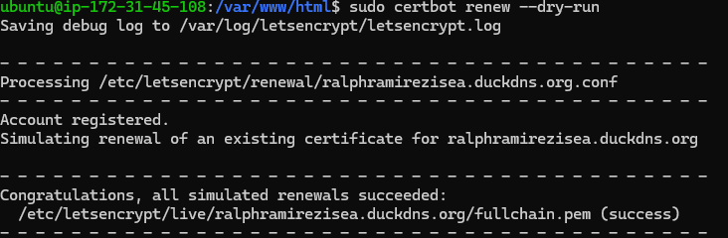
7 | (Optional) Expired Certificate Simulation | Screenshot or explanation of what happens when the cert isn't renewed (if explored)
Hands-on experience with DNS, web hosting, and SSL certificates using entirely free services.

For students learning web hosting, a simple free setup is:
Part 1 – Register a Free Domain Name (DuckDNS)
Step 1: Create a DuckDNS Account
- Go to Duck DNS
- Sign in using:
  - Google
  - GitHub
  - Reddit
  - Twitter/X

Step 2: Create a Subdomain
- Enter a name, e.g.:
mywebapp
- Click Add Domain
- You will receive:
mywebapp.duckdns.org

Step 3: Configure Dynamic DNS
- Install DuckDNS client on your server/VM.
- Obtain your DuckDNS token.
- Configure periodic updates.
Example Linux command:
mkdir ~/duckdns
cd ~/duckdns
nano duck.sh
Paste:
echo url="https://www.duckdns.org/update?domains=mywebapp&token=YOURTOKEN&ip=" | curl -k -o ~/duckdns/duck.log -K -
Make executable:
chmod 700 duck.sh
Test:
./duck.sh
Verify:
nslookup mywebapp.duckdns.org

Part 2 – Install a Web Server
Ubuntu:
sudo apt update
sudo apt install nginx -y
Check:
systemctl status nginx
Browse to:
http://SERVER-IP
You should see the Nginx welcome page.

Part 3 – Point Domain to Server
Check current IP:
curl ifconfig.me
Verify:
ping mywebapp.duckdns.org
The IP should match your server's public IP.

Part 4 – Open Firewall Ports
Allow:
Port | Purpose
80 | HTTP
443 | HTTPS
Ubuntu:
sudo ufw allow 80
sudo ufw allow 443
sudo ufw enable
Cloud VM:
- AWS Security Group
- Azure NSG
- Google Cloud Firewall
Must also allow TCP 80 and 443.

Part 5 – Obtain Free SSL Certificate (Let's Encrypt)
Install Certbot:
sudo apt update
sudo apt install certbot python3-certbot-nginx -y
Request certificate:
sudo certbot --nginx -d mywebapp.duckdns.org
Provide:
- Email address
- Accept Terms
Certbot will:
- Verify domain ownership
- Install certificate
- Configure HTTPS

Part 6 – Test HTTPS
Open:
https://mywebapp.duckdns.org
You should see:
🔒 Secure Connection

Part 7 – Verify Certificate
Check:
sudo certbot certificates
Example:
Certificate Name: mywebapp.duckdns.org
Expiry Date: 2026-09-10

Part 8 – Auto-Renew SSL
Test renewal:
sudo certbot renew --dry-run
Check timer:
systemctl list-timers | grep certbot
Let's Encrypt certificates renew automatically every 90 days.

Architecture Diagram
Student Browser
|
| HTTPS (443)
v
mywebapp.duckdns.org
|
v
DuckDNS DNS Service
|
v
Public IP Address
|
v
Nginx Web Server
|
v
Student Website

Lab Deliverables
Students should submit:
- Screenshot of DuckDNS domain creation
- Screenshot of ping mywebapp.duckdns.org
- Screenshot of Nginx running
- Screenshot of HTTPS browser padlock
- Output of:
sudo certbot certificates
- Short explanation:
  - What is DNS?
  - What is a domain name?
  - What is SSL/TLS?
  - Why use HTTPS instead of HTTP?
  - What does Let's Encrypt provide?

